Controlling nonlinear instabilities in Bessel beams through longitudinal intensity shaping
Ismail Ouadghiri-Idrissi, John M. Dudley and Francois Courvoisier*
¹FEMTO-ST Institute, Univ. Bourgogne Franche-Comté, CNRS UMR 6174
15B avenue des Montboucons, 25030 Besançon, cedex, France.
*Corresponding author: francois.courvoisier@femto-st.fr

During ultrafast laser pulse propagation in dielectrics, the nonlinear generation of new spatial frequencies can be deleterious to reach high intensities and to generate uniform plasma channels. In this context, diffraction-free Bessel beams have attracted major recent interest because of their enhanced stability when compared to conventional Gaussian beams. However, Bessel beams can still suffer from significant modulation instability arising from noise-induced nonlinear four-wave mixing. In this Letter, we report control of the nonlinear instability growth by shaping the longitudinal intensity profile of the incident field. Our results show that tailored longitudinal intensity shaping of a non-diffracting Bessel beam can strongly reduce four wave mixing induced oscillations and stabilize nonlinear propagation at ablation-level intensities.
Diffraction-free (or diffraction-resistant) Bessel beams exploit conical energy flow to yield a near-uniform intensity distribution along a line focus. [1]. They can be viewed as arising from cylindrically-symmetric wave interference, where a central high intensity core is surrounded by concentric circular lobes of lower intensity. They are characterized by a conical flow of energy, which yields a uniform intensity distribution over a line focus. Practical finite-energy Bessel beams such as Bessel-Gauss beams, still maintain a quasi-invariant intensity profile, obviously over a finite distance.
A particularly important property of Bessel beams in the regime of ultrafast nonlinear pulse propagation is that they can sustain quasi-invariant regimes of filamentation where nonlinear losses within the central main lobe are compensated by energy transfer from the side lobes [2-4] .
Although femtosecond Bessel beams have found significant applications in controlled nonlinear ablation and transparent material modification [5,6], a primary drawback is that Bessel-like beams can still suffer from significant nonlinear (modulation) instability at very high intensities [3,7]. This is particularly the case when nonlinear absorption (which can act as a stabilizing mechanism) is low, which can occur for moderate or low focusing Bessel beam cone angles [2,3] (typically below 9° in glass [8]). Kerr-related nonlinearities then dominate the dynamics and the propagation is no longer stationary. Under such circumstances, the intensity of the central core significantly oscillates along the propagation direction, which is clearly detrimental for applications such as the generation of longitudinally-extended plasmas [9-11] or laser material processing [7,8,12-15]. In this non-stationary regime, the intensity oscillation has been previously described as arising from the nonlinear generation of two new spatial frequencies [3,16] Specifically, four-wave mixing was identified as the source of new frequencies generated around 0 and 2^{1/2} k_{r0}, where k_{r0} is the central spatial frequency of the linear Bessel beam [3,16,17]. It is the control of the generation of these four wave mixing spatial frequency components via longitudinal beam shaping that is the primary result of this work.
To introduce our approach, we plot in Fig. 1 the result of a numerical simulation of a finite distance Bessel-Gauss beam propagating in glass in a non-stationary regime. More detail of the model is given further below. In Fig. 1(a), we plot the intensity as a function of radial distance r and propagation distance z. The on-axis intensity is shown in Fig. 1(b), where the oscillations are clearly apparent. In Fig 1(c) the spatial spectrum is plotted as a function of propagation distance and we observe that while the spatial spectrum initially contains only one distinct peak at k_{r0}, this central peak is itself before the generation of new spectral components around k_{r}~0 and k_{r}~2^{1/2}k_{r0} It is the interference between these novel two components with the main Bessel component k_{r0}=0.55 µm⁻¹ that creates the deleterious on-axis oscillations of the intensity [3,7,16,17] with a period of $λ/{n\left(1-\cos{θ}\right)}$~200 µm, where $λ$ is the wavelength, $n$ the index of refraction and θ the cone angle [3,16,18].
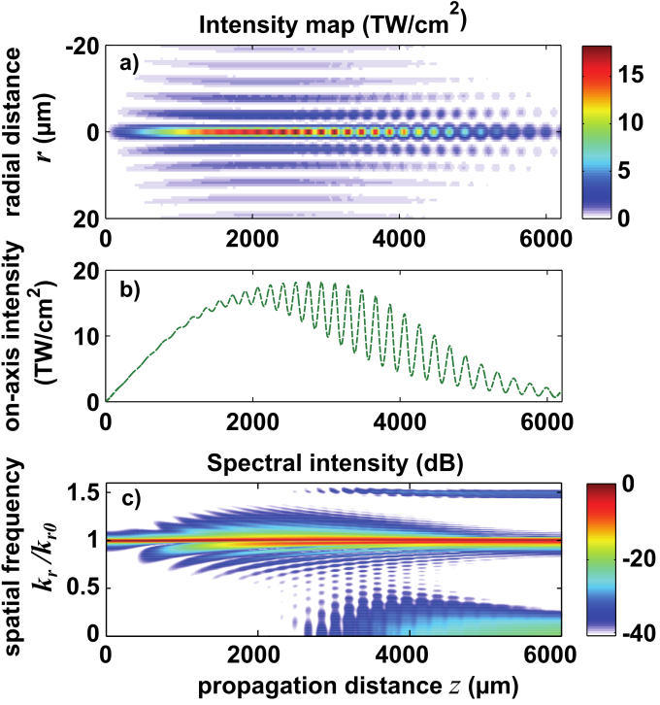
Fig. 1 (a) Intensity distribution of a Bessel-Gauss beam propagating in a pure nonlinear Kerr medium (n₂ = 2.48 10⁻¹⁶ cm²/W), as a function of radial distance r and propagation distance z, b) the corresponding on-axis intensity and c) the spatial spectrum distribution along the propagation distance; input power: P_{in} = 47.6 MW, beam waist: w₀ = 300 µm and cone angle θ = 4°.
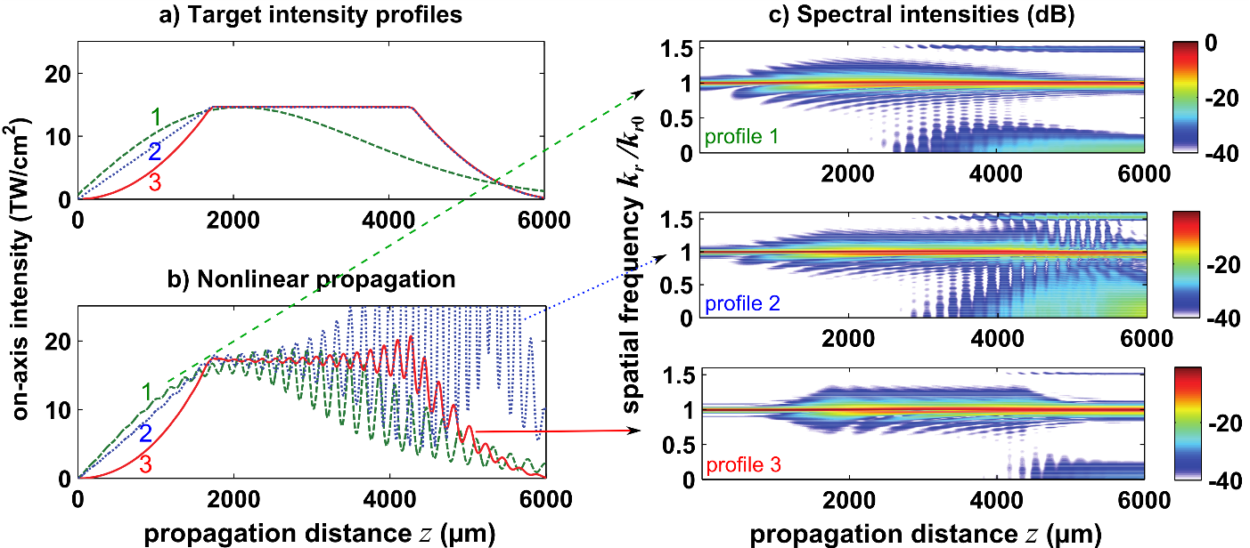
In previous studies, the transition between stationary and non-stationary regimes was controlled by adjusting the cone angle and input pulse energy [2,3,8]. In [17], the progressive buildup of the Bessel-Gauss beam inside a nonlinear medium was compared to an abrupt launch at the peak intensity of the Bessel Beam into the nonlinear medium. The latter case showed extremely high instability in contrast with the former. However, applications in material processing often require specific values of the cone angle and peak intensity. Here we show that these oscillations can be significantly reduced through appropriate shaping of the longitudinal intensity profile of the input Bessel beam. Specifically, it is well known that the longitudinal intensity profile of a Bessel beam can be varied by shaping its spatial spectrum [19-21]. Indeed, it is experimentally possible to generate such shaped beams even at high intensity by using a recently developed technique based on phase-only shaping, which preserves energy throughput [22]. Here, for the first time to our knowledge, we study the nonlinear propagation of Bessel Gauss beams in terms of specific input target longitudinal profiles (the on-axis intensity profiles the beam would reach during linear propagation). We first numerically compare the nonlinear propagation of three different target profiles. We then interpret our results based on the input spatial spectral phase distributions. Finally, we show that our conclusions are also valid in the filamentation regime when plasma interaction is also considered.
We show in Fig. 2(a) the three target on-axis intensity profiles that we will compare with identical cone angles of θ = 4°. They were chosen so that the peak intensity is the same and reached at the same propagation distance z. First, the green dashed line is the Bessel-Gauss profile of Fig. 1. The second profile, represented as a blue dotted line, consists of a linear ramp followed by a constant intensity plateau and a parabolic decay. The third profile (red solid line) consists of a parabolic increase, followed by the same plateau of constant intensity and parabolic decay as in the second profile. As we will see later, a key parameter is the profile of the initial intensity rise, which we can now straightforwardly compare between these three cases.
We model the nonlinear propagation by the nonlinear Schrödinger equation including only nonlinear Kerr effect, which we first numerically solve in continuous wave model with a split-step scheme assuming cylindrical symmetry [23,24]. Given the short propagation distances considered (~ mm), dispersion is neglected. Numerical parameters correspond to propagation in fused silica and are given in Fig. 1.

Fig. 2 Simulation of the nonlinear propagation of three Bessel beams with different a) target on-axis intensity profiles. Evolution of their respective b) on-axis intensities and c) spatial spectra along propagation. The green dashed line (profile 1) is the same as in Fig. 1.

Figures 2(b) and 2(c) compare the nonlinear propagation of the different profiles. We readily observe in Fig. 2(b) that the on-axis intensities exhibit very different behavior and that the peak oscillations are greatly reduced for profile 3 (solid red line, characterized by a parabolic intensity rise.) It is even more apparent from the evolution of the spatial spectra with distance, as shown in Fig. 2(c). In the case of profile 3, the appearance of the spectral components at k_{r}~0 and k_{r}~2^{1/2}k_{r0} occurs only at a propagation distance z above 4000 µm and is one order of magnitude (10 dB) lower than for the other two profiles.
The strong reduction of the on-axis oscillations observed for profile 3 (parabolic rise) in Fig. 2 (b) prompts the question of its origin. It could be viewed as the reduction of the length over which the intensity is high enough to generate efficient FWM in comparison with the other two profiles (1 and 2). However, additional simulations show that this argument does not capture the process. Indeed, we compare in Fig. 3(a) the parabolic rise with another profile 4, where the initial intensity rise is chosen to be z⁴. It is apparent that the parabolic intensity increase is the best case to reduce the nonlinear growth, even if the profile with rise in z⁴ reaches high intensities over an even more reduced propagation range in comparison with profile 2.
Here, we show that the input spatial spectral phase is a dominant parameter. It is known that phase matching drives the efficiency of the four-wave mixing process [25]. In Fig. 3 (b,c), we compare the spatial spectra (amplitude and phase) of the input beams. The amplitude spectra are nearly identical for profiles 2-4. From independent simulations in the linear regime, we have determined that the spectral range where the phase affects the intensity profile by more than 5% is k_{r}/k_{r0}~[0.8-1.2]. In this range, we observe that the unwrapped spatial phase profile at z=0 which shows the largest slope is the one with the parabolic rise (profile 3).
We interpret the low-intensity tails of the spectra as input signals components for the FWM process, while the pump is the main peak of the spectral amplitude. During the intensity rise, the phase mismatch of profile 3 between the pump (main spectral peak) and signals (other spectral components), as can be seen in Fig. 3(c), enables the reduction of four-wave mixing during the intensity rise region (z=0-1800µm). This leads to reduced spectral broadening around the pump and therefore to reduced FWM later in the propagation.
This behavior is in contrast with the other profiles, particularly profiles 1 and 2 where the input spectral phase shows much less extent and yields FWM with much higher efficiency. This explains the stronger oscillations observed for the nonlinear propagation of these profiles.
The amount of FWM for each case can be ranked with the slope of the initial input spectral phase profile, i.e. decreasing efficiency for the profiles in the order 2, 4 and 3. We have independently verified that the small oscillations in the spectral phase of profile 3 have negligible influence on the FWM efficiency and verified our assertion with other input profiles (not shown, intensity rise in z^{1.5}, z^{2.5}, as well as with different intensity decrease, etc). To compare profiles 1 and 2, we must take into account the fact that their amplitude spectra largely differ, while they show a comparable phase profile. Since the characteristic length of the Bessel zone is longer for profile 2 than for profile 1, its spectrum is thinner, which renders the FWM more efficient.
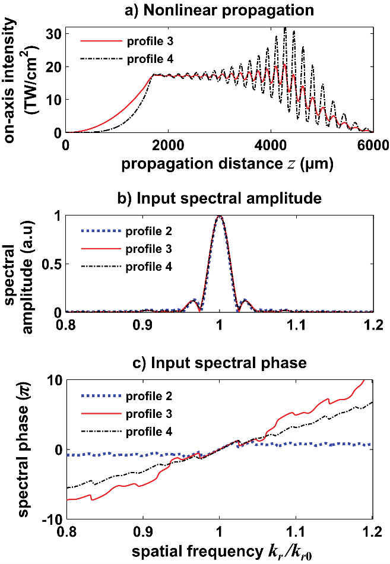
Fig. 3 (a) Nonlinear propagation of two Bessel beams whose on-axis intensity shapes follow profile 3 (red line) and profile 4 (dashed-dotted black line). Plot of the corresponding input spectral (b) amplitude and (c) phase distributions in comparison with profile 2 (blue dotted line of Fig. 2).

It is important to note that the intensity rise profile (or equivalently the spectral phase) has an importance only when the intensity rise takes place in a nonlinear medium. If the nonlinear regime is started at the point where all target profiles (2-4) are the same, then the generation of novel spatial frequencies is the same for all profiles. This is because in the propagation regions of the flat plateau and the parabolic decrease, the profiles 2-4 are identically produced by the same phasing of spectral components.
We have also confirmed that changing the peak intensity of the plateau does not change any of the conclusions drawn above: the input phase variation is the most relevant parameter to characterize the nonlinear growth of FWM among the considered longitudinal intensity profiles. Additional simulations included intensity noise up to 5 % which had no impact on the relative ranking of the input profiles.
Because the longitudinal high intensity central region of the Bessel beam is continually being regenerated by conical energy flow from oblique angles (i.e. its “self-healing” property [1,6]), then any nonlinear phaseshift developed at the high intensity region on-axis does not in fact accumulate along the z-direction. This precludes self-collapse due to Kerr self-focusing. Therefore, even if high intensities are reached here, the self-collapse of the main lobe or modulation instability developing from noise within the main intensity lobe can be safely discarded.
Our results are still valid for the case of filamentation in solids which is one of our initial motivations. Figure 4 compares nonlinear propagation of profiles 1 and 3 when we include dispersion and terms related to nonlinear losses and plasma generation, using the model of reference [26] for femtosecond pulse propagation in fused silica with the full spatio-temporal model. While the on-axis profiles of the total time-integrated intensity (fluence) are very close, we see that the peak intensity (Fig. 4(b)) exhibits high peaks for the input profile 1 (Bessel-Gauss) in contrast with the second. This naturally yields an important difference in the distributions of the plasma that is generated by nonlinear ionization (Fig. 4(c)). In the first case, the plasma is not homogeneous while it is almost constant along the flat plateau of profile 3.
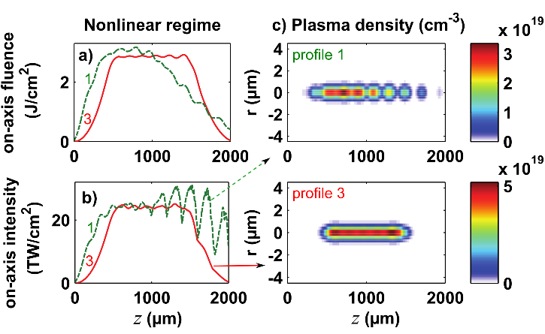
Fig. 4: Nonlinear propagation of two Bessel beams with profile 1 (green dashed line) and profile 3 (red solid line) in the filamentation regime: plot of (a) the on-axis fluence (J/cm²), (b) the peak temporal intensity of the central core along z and (c) evolution of maximal plasma density in transverse and propagation distances for both beams. Input pulse energy: E_{in} =3.6 µJ for profile 1 and E_{in} =3.8 µJ for profile 3, pulse duration 130 fs, beam waist: w₀ = 100 µm and cone angle θ = 4°.
In conclusion, we have shown that controlling the longitudinal intensity profile is an important and novel means of controlling nonlinear propagation and four-wave mixing processes for high intensity Bessel beams. Four-wave mixing processes occurring within Bessel beams were interpreted using the low-intensity tail of the spatial spectra as signal waves. Their relative phase with the main Bessel component at k_{r0} determines the efficiency of the four-wave mixing process. We have demonstrated that the input spatial spectral phase is a parameter even more important than the distance over which high intensities are reached. We believe this approach can be used to control other type of nonlinearities and will foster the use of longitudinally-shaped Bessel beams for laser-plasma control.

Funding. We acknowledge support from the Labex ACTION program (ANR-11-LABX-0001-01) and the European Research Council (ERC-CoG-682032-PULSAR). We thank R. Giust for fruitful discussions.

References
- J. Durnin ,and J. J. Miceli. Phys. Rev. Lett., 58, 15, 1499 (1987).
- M. A. Porras, A. Parola, D. Faccio, A. Dubietis, and P. Di Trapani, Phys. Rev. Lett., 93, 153902 (2004).
- P. Polesana, M. Franco, A. Couairon, D. Faccio, and P. Di Trapani, Phys. Rev. A 77, 043814 (2008).
- K. Dota, A. Pathak, J. A. Dharmadhikari, D. Mathur, and K. Dharmadhikari, Phys. Rev. A, 86, 023808 (2012).
- M. K. Bhuyan, F. Courvoisier, P. A. Lacourt, M. Jacquot, R. Salut, L. Furfaro, and J. M. Dudley, Appl. Phys. Lett. 97, 081102 (2010).
- M. Duocastella, and C. B. Arnold, Laser Photonics Rev. 6, 607 (2012).
- E. Gaizauskas, E. Vanagas, V. Jarutis, S. Juodkazis, V. Mizeikis, and H. Misawa, Opt. Lett. 31, 80–82 (2006).
- M. K. Bhuyan, F. Courvoisier, P.-A. Lacourt, M. Jacquot, L. Furfaro, M. J. Withford, and J. M. Dudley, Opt. Express 18, 566-574 (2010).
- F. V. Bunkin, V. V. Korobkin, Yu. A. Kurinyi, L. Ya. Polonskii, and L. N. Pyatnitskii, Sov. J. Quantum Electron. 13, 2 (1983).
- S. P. Nikitin, I. Alexeev, J. Fan, and H. M. Milchberg, Phys. Rev. E 59, 4 (1999).
- H. Sheng, K. Y. Kim, V. Kumarappan, B. D. Layer, and H. M. Milchberg, Phys. Rev. E 72, 3 (2005).
- J. Amako, D. Sawaki, and E. Fujii, J. Opt. Soc. Am. B 20, 12 (2003).
- M. Mikutis, T. Kudrius, G. Slekys, D. Paipulas, and S. Juodkazis, Opt. Mater. Express 3, 1862 (2013).
- V. Garzillo, V. Jukna, A. Couairon, R. Grigutis, P. Di Trapani, and O. Jedrkiewicz, J. Appl. Phys. 120, 013102 (2016).
- Y. Matushiro, and W. Watanabe, J. Laser Micro. Nanoen 11, 59 (2016).
- R. Gadonas, V. Jarutis, R. Paskauskas, V. Smilgevicius, A. Stabinis, and V. Vaicaitis, Opt. Commun., 196, 309 (2001).
- P. Polesana, A. Couairon, D. Faccio, A. Parola, M. A. Porras, A. Dubietis, A. Piskarskas, and P. Di Trapani, Phys. Rev. Lett., 99, 223902 (2007).
- A. W. Norfolk, and E. J. Grace, Opt. Commun. 283, 447 (2010).
- M. Zamboni-Rached, E. Recami, and H. E. Hernández-Figueroa, J. Opt. Soc. Am. A 22, 2466 (2005).
- T. Cizmar, and K. Dholakia, Opt. Express, 17, 15558 (2009).
- M. Zamboni-Rached, and M. Mojahedi, Phys. Rev. A 92, 043839 (2015).
- I. Ouadghiri-Idrissi, R. Giust, L. Froehly, L. Furfaro M. Jacquot, J.M. Dudley, and F. Courvoisier, Opt. Express, 24, 11495 (2016).
- A. Couairon, E. Brambilla, T. Corti, D. Majus, O. de J. Raminez-Gongora, and M. Kolesik, Eur. Phys. J. Special Topics, 199, 5 (2011).
- M. Guizar-Sicairos, and J. C. Gutierrez-Vega, J. Opt. Soc. Am. A 21, 53-58 (2004)
- R. W. Boyd, Nonlinear Optics, 3rd ed. (Academic, 2008).
- L. Sudrie, A. Couairon, M. Franco, B. Lamouroux, B. Prade, S. Tzortzakis, and A. Mysyrowicz, Phys. Rev. Lett. 89, 4135 (2002).

Full references

- J. Durnin and J. J. Miceli, “Diffraction-free beams,” Phys. Rev. Lett. 58, 15 (1987).
- M. A. Porras, A. Parola, D. Faccio, A. Dubietis, and P. Di Trapani, “Nonlinear unbalanced Bessel beams: Stationary conical waves supported by nonlinear losses,” Phys.Rev. Lett., 93, 153902 (2004).
- P. Polesana, M. Franco, A. Couairon, D. Faccio, and P. Di Trapani, “Filamentation in Kerr media from pulsed Bessel beams,” Phys. Rev. A 77, 043814 (2008).
- K. Dota, A. Pathak, J. A. Dharmadhikari, D. Mathur, and K. Dharmadhikari, “Femtosecond laser filamentation in condensed media with Bessel beams,” Phys. Rev. A, 86, 023808 (2012).
- M. K. Bhuyan, F. Courvoisier, P. A. Lacourt, M. Jacquot, R. Salut, L. Furfaro, and J. M. Dudley, “High aspect ratio nanochannel machining using single shot femtosecond Bessel beams,” Appl. Phys. Lett. 97, 081102 (2010).
- M. Duocastella and C. B. Arnold, “Bessel and annular beams for materials processing,” Laser Photonics Rev. 6, 607–621 (2012).
- E. Gaizauskas, E. Vanagas, V. Jarutis, S. Juodkazis, V. Mizeikis, and H. Misawa, “Discrete damage traces from filamentation of Gauss–Bessel pulses,” Opt. Lett. 31, 80–82 (2006).
- M. K. Bhuyan, F. Courvoisier, P.-A. Lacourt, M. Jacquot, L. Furfaro, M. J. Withford, and J. M. Dudley, "High aspect ratio taper-free microchannel fabrication using femtosecond Bessel beams," Opt. Express 18, 566-574 (2010).
- F. V. Bunkin, V. V. Korobkin, Yu. A. Kurinyi, L. Ya. Polonskii, and L. N. Pyatnitskii, “Laser spark with a continuous channel in air,” Sov. J. Quantum Electron. 13, 2 (1983).
- S. P. Nikitin, I. Alexeev, J. Fan, and H. M. Milchberg, “High efficiency coupling and guiding of intense femtosecond laser pulses in preformed plasma channels in an elongated gas jet,” Phys. Rev. E 59, 4 (1999).
- H. Sheng, K. Y. Kim, V. Kumarappan, B. D. Layer, H. M. Milchberg, “Plasma waveguides efficiently generated by Bessel beams in elongated cluster gas jets,” Phys. Rev. E 72, 3 (2005).
- J. Amako, D. Sawaki, and E. Fujii, “Microstructuring transparent materials by use of nondiffracting ultrashort pulse beams generated by diffractive optics,” J. Opt. Soc. Am. B 20, 12 (2003).
- M. Mikutis, T. Kudrius, G. Slekys, D. Paipulas, and S. Juodkazis, “High 90% efficiency Bragg gratings formed in fused silica by femtosecond Gauss-Bessel laser beams,” Opt. Mater. Express 3, 1862 (2013).
- V. Garzillo, V. Jukna, A. Couairon, R. Grigutis, P. Di Trapani, and O. Jedrkiewicz, "Optimization of laser energy deposition for single-shot high aspect-ratio microstructuring of thick BK7 glass," J. Appl. Phys. 120, 013102 (2016).
- Y. Matushiro and W. Watanabe," Femtosecond Laser Processing of Polymethyl Methacrylate with an Axicon," J. Laser Micro. Nanoen 11, 59 (2016).
- R. Gadonas, V. Jarutis, R. Paskauskas, V. Smilgevicius, A. Stabinis, and V. Vaicaitis, “Self-action of Bessel beam in nonlinear medium,” Opt. Commun. 196, 309–316 (2001).
- P. Polesana, A. Couairon, D. Faccio, A. Parola, M. A. Porras, A. Dubietis, A. Piskarskas, and P. Di Trapani, “Observation of conical waves in focusing, dispersive, and dissipative Kerr media,” Phys. Rev. Lett.. 99, 223902 (2007).
- A. W. Norfolk and E. J. Grace," New beat length for writing periodic structures using bessel beams," Opt. Commun. 283, 447 (2010).
- M. Zamboni-Rached, E. Recami, H. E. Hernández-Figueroa, "Theory of “frozen waves”: modeling the shape of stationary wave fields," J. Opt. Soc. Am. A 22, 2466 (2005).
- T. Cizmar and K. Dholakia., “Tunable Bessel light modes: engineering the axial propagation,” Opt. Express 17, 15558–15570 (2009).
- M. Zamboni-Rached and M. Mojahedi, "Shaping finite-energy diffraction- and attenuation-resistant beams through Bessel-Gauss–beam superposition," Phys. Rev. A 92, 043839 (2015).
- I. Ouadghiri-Idrissi, R. Giust, L. Froehly, L. Furfaro, M. Jacquot, J.M. Dudley, and F. Courvoisier, “Arbitrary shaping of on-axis amplitude of femtosecond Bessel beams with a single phase-only spatial light modulator,” Opt. Express, 24, 11495–11504 (2016).
- A. Couairon, E. Brambilla, T. Corti, D. Majus, O. de J. Raminez-Gongora, and M. Kolesik, “Practitioner’s guide to laser pulse propagation models and simulation, ” Eur. Phys. J. Special Topics, 199, 5 (2011).
- M. Guizar-Sicairos and J. C. Gutierrez-Vega, “Computation of quasi-discrete Hankel transforms of integer order for propagating optical wave fields, ” J. Opt. Soc. Am. A 21, 53-58 (2004).
- R. W. Boyd, Nonlinear Optics, 3rd ed. (Academic, 2008).
- L. Sudrie, A. Couairon, M. Franco, B. Lamouroux, B. Prade, S. Tzortzakis and A. Mysyrowicz “Femtosecond Laser-Induced Damage and Filamentary Propagation in Fused Silica, ” Phys. Rev. Lett. 89, 4135 (2002).

