Elaboration of sensitive carbon monoxide sensors based on cobalt corroleS

Valentin QUESNEAU,¹ Stéphane BRANDES,¹ Nicolas DESBOIS,¹
Meddy VANOTTI,² Virginie BLONDEAU-PATISSIER,² and Claude P. GROS,¹

¹ICMUB (UMR CNRS 6302), Université de Bourgogne Franche-Comté, 9 avenue Alain Savary, BP 47078, 21078 Dijon Cedex, France
²Institut FEMTO-ST Département Temps-Fréquence (FEMTO-ST, UMR CNRS 6174)
26 chemin de l’Epitaphe, 25030 BESANÇON Cedex, France
valentin.quesneau@u-bourgogne.fr, icmub.fr

Keywords: Carbon monoxide; corrole; cobalt; sensors

Summary: Detection of carbon monoxide (CO) at very low levels is a critical point for quality control of domestic and industrial environment. Carbon monoxide, a colorless, tasteless and odorless gas, known as the « silent killer », is responsible of over one hundred deaths per year in France, according to the INPES institute.^{[1]} One another interest of a high sensitive carbon monoxide detector is for PEM (Proton Exchange Membrane) fuel cell application which requires pure dihydrogen to produce energy. Actually, due to its industrial synthesis, some traces (up to 1 %) of carbon monoxide are present in dihydrogen and deactivate the catalyst based on platinum. For these applications, levels lower than 10 ppm had to be detected.
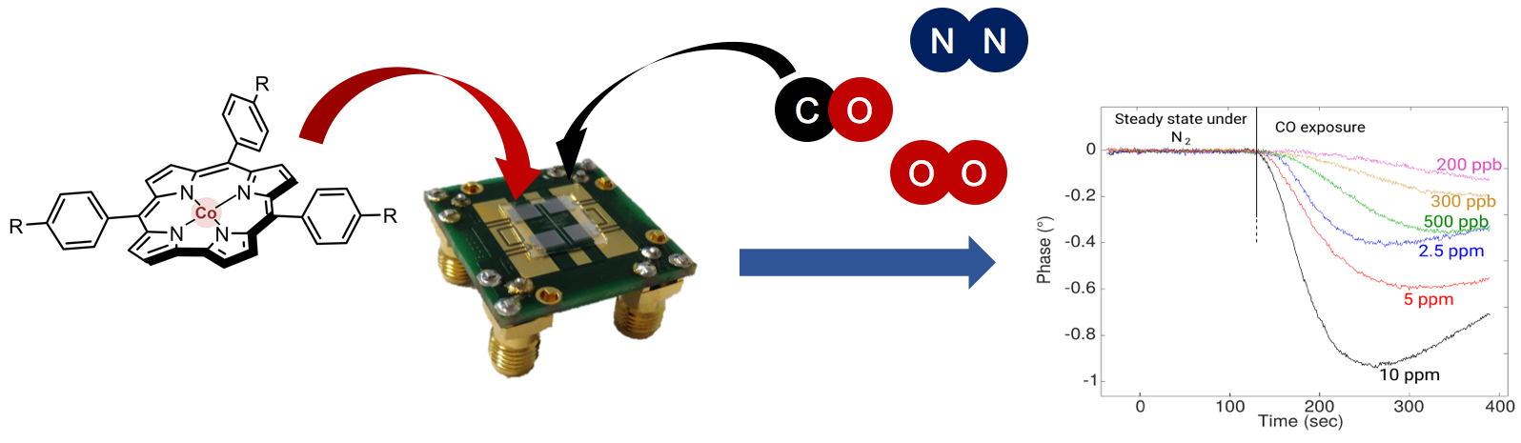
Corroles are molecules belonging to the porphyrinoid family. Such macrocycle has a great interest in coordination chemistry, medical imaging, fluorescence detection of ions or small molecules binding and in catalysis.^{[2]} Corroles usually binds cobalt, that gives to the complex a high binding affinity for carbon monoxide even in the presence of nitrogen and dioxygen, the two major gas components of the atmosphere.^{[3]} Interestingly, cobalt corroles can now be involved in the elaboration of selective and sensitive carbon monoxide detectors.

Fig 1: Carbon monoxide detection with a SAW type sensor.

Our work consists in the synthesis of different cobalt corroles and the study of their coordination properties of carbon monoxide. We have particularly studied the influence of the steric hindrance and the electronic effects of different substituents on the meso-position of the corrole macrocycle. The deposition of their cobalt complexes on a guiding surface of a SAW sensor (Surface Acoustic Wave) was carried out to develop selective CO sensors.^{[4]} Preliminary results give low level carbon monoxide detection and work are still ongoing to develop a procedure that yields a very sensitive and robust sensor.
Authors would like to acknowledge the ANR program (CO3SENS project), the FEDER and the “Région Bourgogne” for financial support, and for the allocation of a PhD grant (JCE program).

References:
1. INPES, http://invs.santepubliquefrance.fr/Espace-presse.
2. C. I. M. Santos, E. Oliveira, J. F. B. Barata, M. A. F. Faustino, J. A. S. Cavaleiro, M. G. P. M. S. Neves and Carlos Lodeiro, J. Mater. Chem. 2012, 22, 13811-13819.
3. J. M. Barbe, G. Canard, S. Brandès, F. Jérôme, G. Dubois, R. Guilard, Dalton Trans. 2004, 8, 1208-1214.
4. M. Vanotti, C. Theron, S. Poisson, V. Quesneau, M. Naitana, V. Soumann, S. Brandès, N. Desbois, C. P. Gros, T. Tran-Thi, V. Blondeau-Patissier; Proceedings 2017, 1(4), 444-447.

